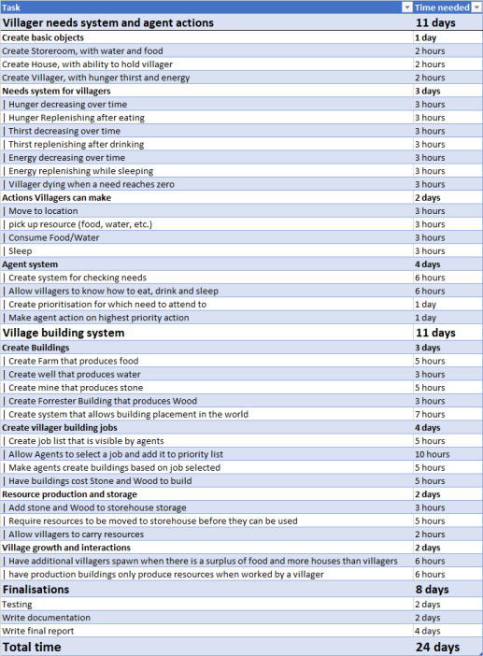

# 4. Project specification

This project will be a settlement management game, based around a small village. The player will have to collect wood and stone to build buildings, as well as collect food, and water to keep the villagers alive. Villagers will seek out food, water and shelter when needed, and will perform tasks from a task list populated by the player.

## Game world

The game world be a simple area with the starting village in the centre, giving the player room to expand. It will be limited in size for this project, as there is limited amounts the player could achieve with a larger amount of space. The world will have 4 major zones, Rocky, fields, forest and floodplains. Each with a benefit or a deficit to buildings built there, which will be described

## Resources

Resources will be a primary mechanic of the game, being what is used to create buildings as well as what is used to keep villagers alive.

|  |  |
| --- | --- |
| Water | |
| Purpose | Drunk by villagers to survive |
| Produced by | Well building |
| Description | One of the primary resources consumed by villagers to stay alive |

|  |  |
| --- | --- |
| Food | |
| Purpose | Eaten by villagers to survive |
| Produced by | Farm building |
| Description | One of the primary resources consumed by villagers to stay alive |

|  |  |
| --- | --- |
| Wood | |
| Purpose | **Used in construction of some buildings** |
| Produced by | Forrester building |
| Description | One of the resources used to produce buildings |

|  |  |
| --- | --- |
| Stone | |
| Purpose | **Used in construction of some buildings** |
| Produced by | Mine building |
| Description | One of the resources used to produce buildings |

|  |  |
| --- | --- |
| Energy | |
| Purpose | **Used by villagers to perform tasks** |
| Produced by | Villagers sleeping |
| Description | As villagers perform tasks, they will expend energy, they restore this energy by sleeping |

|  |  |
| --- | --- |
| Work hours | |
| Purpose | **What workers produce by performing tasks in building or using buildings** |
| Produced by | Villagers |
| Description | One of the resources used to produce buildings.  Work hours will be an “invisible” resource, not actually being shown to the player, instead driving the mechanics of the game in the back end. |

## Buildings

There will be 6 buildings, a mine for producing stone, a Forrester for producing wood, a farm for producing food and a well for producing water, a storehouse for storing wood, stone, food and water, and a house for villagers to sleep in.

|  |  |
| --- | --- |
| Mine | |
| Purpose | Produces stone |
| Requires | Wood to build, villager to operate |
| Spawns at start of the game? | No |
| Best zone | Rocky |
| Worst Zone | Floodplains |
| Description | One of 4 production buildings, designed to produce stone at the expense of villager time.  The mine will be one of the larger buildings in the game |

|  |  |
| --- | --- |
| Forrester | |
| Purpose | Produces Wood |
| Requires | Stone to build, villager to operate |
| Spawns at start of the game? | No |
| Best zone | Forrest |
| Worst Zone | Fields |
| Description | One of 4 production buildings, designed to produce wood at the expense of villager time. |

|  |  |
| --- | --- |
| Farm | |
| Purpose | Produces Food |
| Requires | Wood and stone to build, villager to operate |
| Spawns at start of the game? | Yes |
| Best zone | Fields |
| Worst Zone | Rocky |
| Description | One of 4 production buildings, designed to produce food at the expense of villager time. |

|  |  |
| --- | --- |
| Well | |
| Purpose | Produces Water |
| Requires | Stone to build, villager to operate |
| Spawns at start of the game? | Yes |
| Best zone | Floodplains |
| Worst Zone | Forest |
| Description | One of 4 production buildings, designed to produce water at the expense of villager time. |

|  |  |
| --- | --- |
| Storehouse | |
| Purpose | Stores water, food, stone and wood |
| Requires | Stone and wood to build |
| Spawns at start of the game? | Yes |
| Best zone | N/A |
| Worst Zone | N/A |
| Description | A storehouse is where villagers will store and pick up all resources. As villagers will need to go to storehouses to collect resources for building as well as eating and drinking, these will make up the core of villages |

|  |  |
| --- | --- |
| House | |
| Purpose | Give villagers a place to sleep |
| Requires | Stone and wood to build |
| Spawns at start of the game? | Yes |
| Best zone | N/A |
| Worst Zone | N/A |
| Description | The house will provide a villager a place to sleep, as well as increasing the maximum population size of the village |

|  |  |
| --- | --- |
| Construction site | |
| Purpose | Built into other buildings |
| Requires | Varies |
| Spawns at start of the game? | No |
| Best zone | N/A |
| Worst Zone | N/A |
| Description | When a building is placed down by player, a construction site appears, a villager must then bring the needed resources to it and build it. |

## Villager Actions

The Game will revolve around what actions a villager can do and what that action will achieve, these will mostly be eating, drinking as well as building and using buildings. But also, the other actions in between these that make them possible.

|  |  |
| --- | --- |
| Move to | |
| Prerequisites | Energy |
| Description | Allows to villager to reach a destination to perform other actions |

|  |  |
| --- | --- |
| Pick up resource | |
| Prerequisites | Energy, resource in range to pick up |
| Description | A resource in range is removed and then added to the villager’s inventory |

|  |  |
| --- | --- |
| Drop off resource | |
| Prerequisites | Energy, resource in villager’s inventory |
| Description | A resource is removed from villager inventory and added to building’s inventory in range |

|  |  |
| --- | --- |
| Eat food | |
| Prerequisites | Energy, Food in inventory |
| Description | Food is removed from villager inventory and villager hunger is decreased |

|  |  |
| --- | --- |
| Drink water | |
| Prerequisites | Energy, water in inventory |
| Description | Water is removed from player inventory and villager thirst is decreased |

|  |  |
| --- | --- |
| Sleep | |
| Prerequisites | House |
| Description | Villager stays in house for a period of time while energy is increased |

|  |  |
| --- | --- |
| Build | |
| Prerequisites | Energy, construction site with resources |
| Description | Removes resources from construction site and adds work hours onto construction, if work hours meet a threshold, where it then turns into the desired building. |

|  |  |
| --- | --- |
| Use building | |
| Prerequisites | Energy, Farm building |
| Description | Adds work hours to a building, that is then turned into resources at a ratio, based on the building. |

|  |  |
| --- | --- |
| Find job | |
| Prerequisites | Energy, Job list not empty |
| Description | Selects job from job list |

## Villager Goals

Villagers behaviour is based off goal achievement. They will always try to achieve the goal with the highest priority. As a goal goes unachieved its priority will increase, along with other factors based on that goal until it is the one with the highest priority.

|  |  |
| --- | --- |
| Eat food | |
| Priority increased by | Hunger increasing, having food in inventory |
| Goal achieved by | Hunger decreasing |
| Prerequisites to act on | Having food in inventory |

|  |  |
| --- | --- |
| Drink water | |
| Priority increased by | Thirst increasing, having water in inventory |
| Goal achieved by | Thirst decreasing |
| Prerequisites to act on | Having water in inventory |

|  |  |
| --- | --- |
| Get food | |
| Priority increased by | Hunger increasing, not having food in inventory |
| Goal achieved by | Having food in inventory |
| Prerequisites to act on | Being at storehouse |

|  |  |
| --- | --- |
| Get water | |
| Priority increased by | Thirst increasing, not having water in inventory |
| Goal achieved by | Having water in inventory |
| Prerequisites to act on | Being at storehouse |

|  |  |
| --- | --- |
| Complete Job | |
| Priority increased by | Having a job queued |
| Goal achieved by | Job being completed |
| Prerequisites to act on | Having a job queued |

|  |  |
| --- | --- |
| Get job | |
| Priority increased by | Not having a job queued |
| Goal achieved by | Gaining a job |
| Prerequisites to act on | Job in queue to be picked up |

|  |  |
| --- | --- |
| Get Stone | |
| Priority increased by | Having a job that requires stone |
| Goal achieved by | Having stone in inventory |
| Prerequisites to act on | Having a job that requires stone, having an empty inventory |

|  |  |
| --- | --- |
| Get Wood | |
| Priority increased by | Having a job that requires wood |
| Goal achieved by | Having wood in inventory |
| Prerequisites to act on | Having a job that requires wood, having an empty inventory |

|  |  |
| --- | --- |
| Empty inventory | |
| Priority increased by | Having something in your inventory, no job queued |
| Goal achieved by | Having an empty inventory |
| Prerequisites to act on | Being at storehouse |

|  |  |
| --- | --- |
| Pickup resources from building | |
| Priority increased by | Having an empty inventory |
| Goal achieved by | Dropping off resource at storehouse |
| Prerequisites to act on | Being near resource building |

|  |  |
| --- | --- |
| Be at Building | |
| Priority increased by | Actions failing |
| Goal achieved by | Arriving at specified building |
| Prerequisites to act on | Energy |

# Flow charts

## Agent decision making

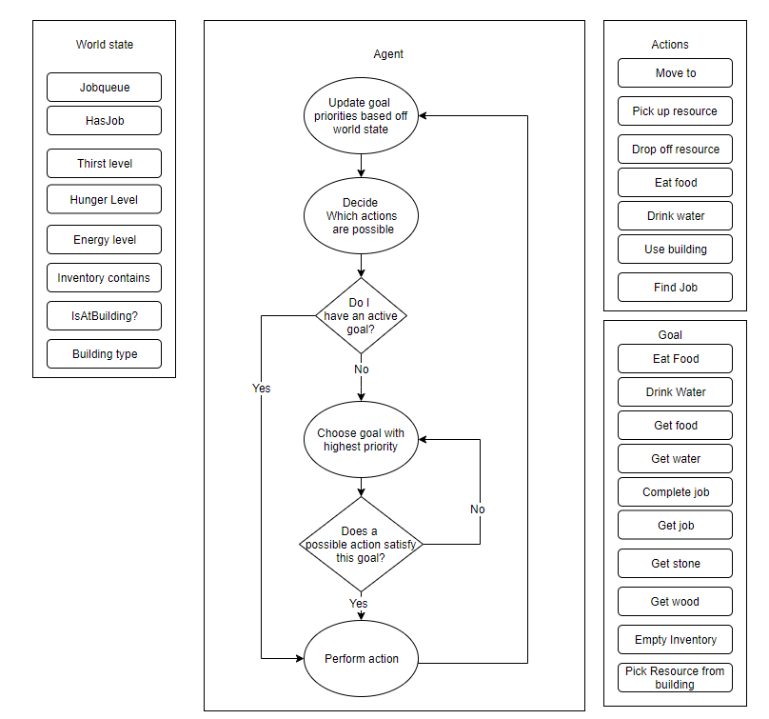

## “Move to” villager action

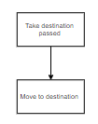

## “Pick up resource” villager action

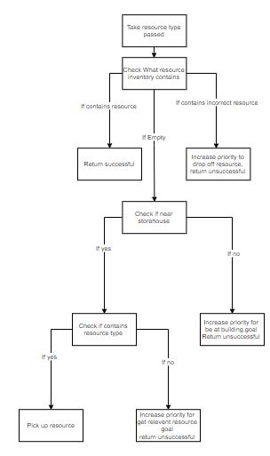

## “Drop off resource” villager action

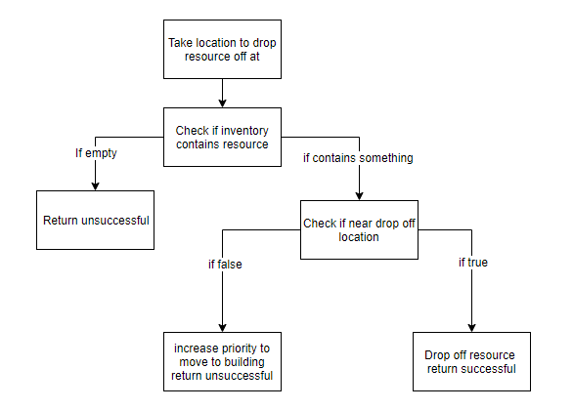

## “Eat food” villager action

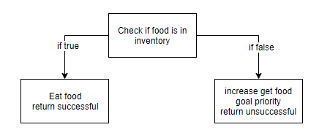

## “Drink water” villager action

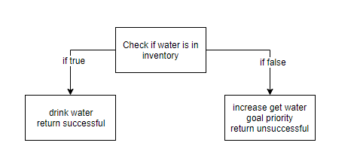

## “Use building” villager action

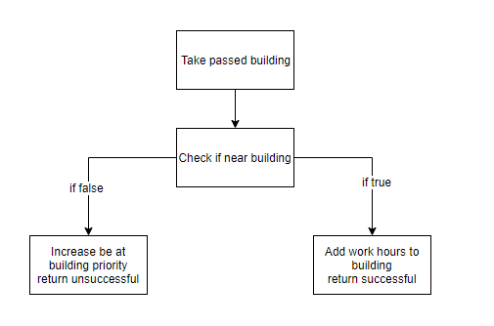

## “find job” villager action

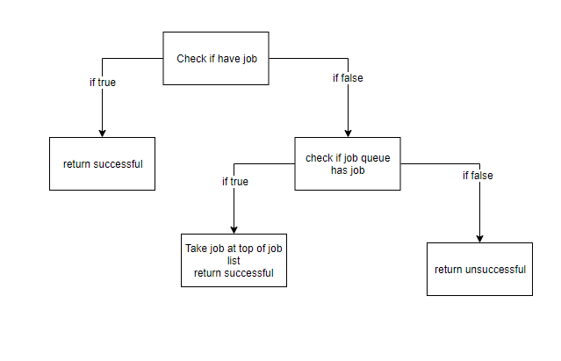

# 7. Pseudocode

